**Blog: Walk through your first HTML page**

**Send Feedback**

We have learned about some basic tags of HTML and how they can be used with each other in combination.

So get ready to make use of everything you have learned so far, without much help. It's your test time.

Don't worry, some basic info is provided below in steps that you can follow. You can also take these steps as steps of how actually pages are built.

The content to be added is provided in the file. The expected look of the blog page and the images required are provided below.

**Steps to follow -**

1. Create HTML structure with the title of the blog as - 'Walk through your first HTML page | blog.codingninjas.in'.

2. Create a basic structure(or sections) of the blog from 'div' tag only using the expected blog image provided.

3. Now add content to it using appropriate tags. Content is provided in the file itself.

4. Now add the images using the assets provided. Add alternate texts to them as well.

**For some content in the blog, existing tags that you have learned might not be enough so its a challenge for you! Explore and google about some tags/special characters to figure this out. For eg. -> read about &lt, &gt. (If you can't figure out, don't worry we will cover them in upcoming lecture).**

**Expected blog page is -**

[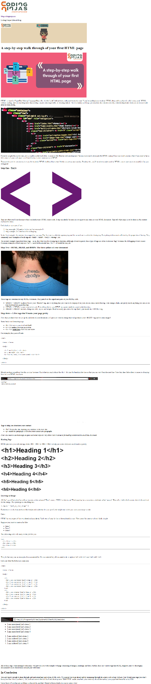](https://ninjasfiles.s3.amazonaws.com/0000000000001479.png)

**The images required are -**

[](https://ninjasfiles.s3.amazonaws.com/0000000000001394.png)

[](https://ninjasfiles.s3.amazonaws.com/0000000000001395.png)

[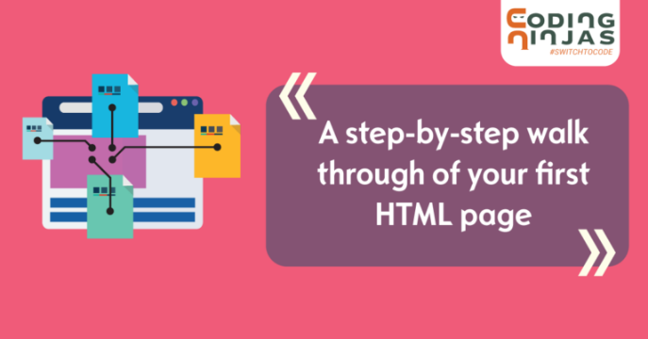](https://ninjasfiles.s3.amazonaws.com/0000000000001491.png)

[](https://ninjasfiles.s3.amazonaws.com/0000000000001486.jpeg)

[](https://ninjasfiles.s3.amazonaws.com/0000000000001485.png)

[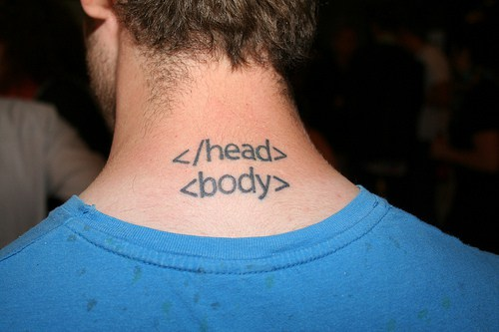](https://ninjasfiles.s3.amazonaws.com/0000000000001488.jpg)

[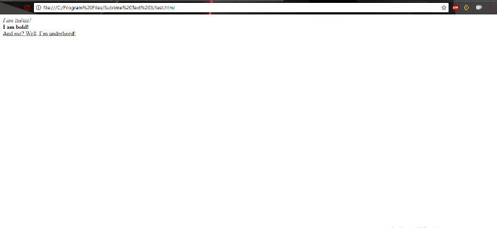](https://ninjasfiles.s3.amazonaws.com/0000000000001490.png)

[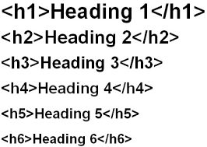](https://ninjasfiles.s3.amazonaws.com/0000000000001487.png)

[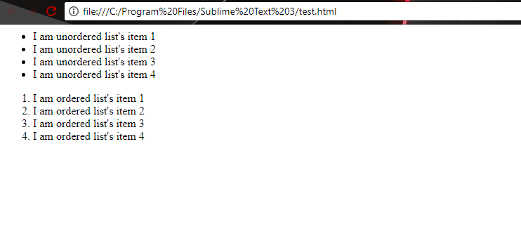](https://ninjasfiles.s3.amazonaws.com/0000000000001489.png)